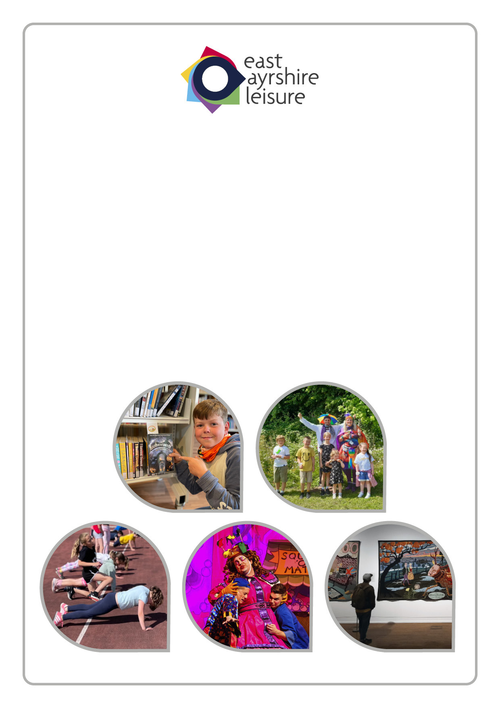
Health & Safety Report
Quarter 4
1 January – 31 March 2025

Contents

- Introduction

- Purpose and Background of Report

- Health and Safety Update
3.1 Helpdesk
3.2 Safety Standards
3.3 Safety Updates
3.4 Fire Risk Assessments

- Support and Wellbeing

- Health and Safety Performance
5.1 Proactive Monitoring
5.2 Organisational Learning

6. Statistical Analysis Overview

7. Average Days to Report an Incident

8. Days Lost due to Workplace Injury

9. Comparative Analysis

10. Conclusions

1. INTRODUCTION
  - The Trust operates policies and systems to ensure the continued health, safety, welfare and development of our workplaces and to minimise the distress and disruption caused by any injuries or work related illnesses which may occur.

  - The Health, Safety and Wellbeing Policy, along with Standards and Procedures are developed and communicated to ensure continued development of a positive health and safety culture across the Trust and promote safe working practices.

  - The Trust provides its employees with safe working conditions and has effective management arrangements in place to ensure the wellbeing of staff and others who may be affected by our activities.

  - A systematic performance management approach, allows incidents and near misses to be analysed, with any potential trends or patterns identified and used to inform decisions regarding appropriate action to mitigate any future risk to employees.

  - The Health & Safety Strategy Group meets on a quarterly basis and is chaired by the Executive Lead; People, Policy & Performance, Trade Union Representative, Strategic Lead; Protecting Our Environment, Development Officer; Sustainability and nominated staff from across the Trust’s services and is supported by the Council’s Corporate Health & Safety Team.

  - The purpose of the group is to monitor Health & Safety Performance, develop Health and Safety Strategy and ensure a consistent approach across the Trust.

- PURPOSE OF THE REPORT

  - To include an update to the Board on the corporate health and safety service provided internally and externally to the Trust.

  - To inform the Board of recent legislative changes and events of general significance occurring both within and outwith East Ayrshire Leisure.

  - To include a statistical analysis based on accidents, incidents and near misses during the specified period and provide comparative information.

  - To identify any potential trends or patterns, thereby encouraging a proactive approach to Safety Management.

  - To share areas of good practice for improved health and safety performance and culture throughout.

3. HEALTH AND SAFETY UPDATE

3.1 Helpdesk

The Health and Safety Team received a total of 21 enquiries from the Trust during Quarter 4 (2024/25). The graph below illustrates the ‘Type’ of enquiries received:

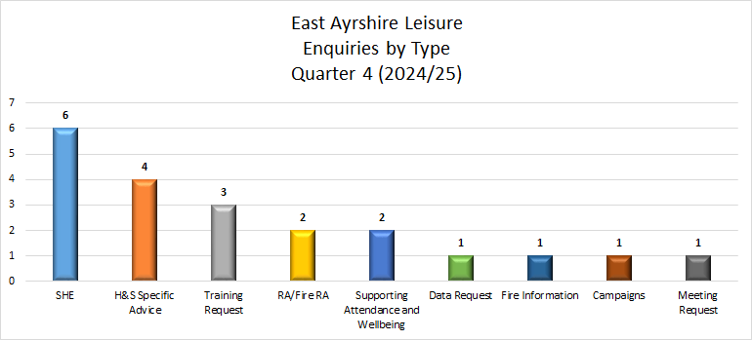

3.2 Health and Safety Standards

During Quarter 4 (2024/25) there were 2 standards released by the Council;

- Consultation and Engagement
- Working at Height

East Ayrshire Leisure, supported by the corporate Health and Safety team, have developed their own suite of H&S standards to accompany the Health, Safety and Wellbeing Policy and can be accessed here.
There were 2 Health and Safety Standards updated during Quarter 4 (2024/25):
- Display Screen Equipment – here
- Vibration at Work - here

3.3 Safety Updates

There was 1 Protocol updated during Quarter 4 (2024/25).

All Protocols are available here
Adverse Weather Protocol – here

There were 4 Bulletins issued during Quarter 4 (2024/25):

- Accident Investigation and Risk Assessment Training Dates
- Early Intervention Pilot Reminder
- Free Yoga Session
- Stress Awareness Month

There were 2 Safety Flashes issued during Quarter 4 (2024/25):

- Council fined for failing to control risks from vibrating tools
- Waste Company failed to protect workers and the public from safety risks

All Safety Flashes and Bulletins are available at:
http://eacintranettest/services/healthandsafety/bulletins/bulletins-2025.aspx
http://eacintranettest/services/healthandsafety/safetyflash/safety-flash-2025.aspx

3.4 Fire Risk Assessments Reviewed

All premises occupied by employees of East Ayrshire Leisure have a current Fire Risk Assessment. There were 5 Fire Risk Assessment reviews carried out during Quarter 4 (2024/25):

- Cumnock Town Hall
- Dalrymple Pavilion
- Kay Park Ochiltree Site
- Merlin Park Pavilion
- The Jougs, Kilmaurs

4. SUPPORT AND WELLBEING

4.1 As an employer it is important to maintain and improve the health, safety and wellbeing of all employees by encouraging a healthier, safer and supportive working environment. The Trust identified this as one of our main priority areas in our 10 year Strategic Vision Document, under our theme of Investing in Our People and Embracing Our Values.

4.2 In order to achieve this theme, we established the following Strategic Objectives:
  - To develop and embed our People Strategy so that employees at all levels are engaged and can contribute to the business
  - To offer work placements, volunteering and apprenticeships

  - To integrate our values into all aspects of our business including the Review and Development programme and recruitment, training and meetings. To focus on skills, knowledge and experience in the development of our business and to ensure we invest in industry specialist training which is tailored to meet the needs of our programmes

4.3 Our staff intranet has a Support & Wellbeing section with key information and links to additional support mechanisms. The staff newsletter regularly features information and direct links relating to these supports.

4.4 The Wellbeing Newsletter is issued to employees once a month and during Quarter 4 (2024/25), the following information was included:
- Bereavement Support
- British Summer Time begins
- Caring responsibilities
- Cervical cancer prevention
- Early intervention for stress
- Employee Counselling
- Endometriosis Awareness Month
- Friendly February!
- Health Checks
- Healthy Eating
- Improving sleep
- International Day of Happiness
- International Women's Day
- Mind to Mind
- Mindful March
- Mindfulness
- National No Smoking Day
- New Early Intervention Process
- New Year, new you?
- Physical Wellbeing
- Random Acts of Kindness Day
- Sexual Abuse and Sexual Violence Awareness week
- Supporting Attendance and Wellbeing Session for Managers
- Wellbeing Courses
- Work-life balance
- Workplace Wellbeing Action Plan

HEALTH AND SAFETY PERFORMANCE
5.1 Proactive Monitoring
Together with the reactive monitoring of accidents and incidents, proactive monitoring enables managers to assess Services’ performance in managing health and safety. It then assists in providing a focus for the planning and implementing of risk improvements, thereby reducing the number of incidents. Our Organisational Learning framework is one of the mechanisms used by the organisation.

- Unannounced Visits/Inspections
During Quarter 4 (2024/25) there were no unannounced visits carried out by the senior management team of East Ayrshire Leisure.

5.2 Organisational Learning
Organisational Learning is our process which analyses feedback from events and activities, staff and customer comments and complaints, venue visits, audits and external accreditation schemes as well as drawing on information from H&S and SHE reports. This process allows us to identify any re-occurring issues or themes, identify any additional training requirements or measures which need to be put in place. Action plans are pulled together quarterly, discussed at Management Team Meetings and reported annually to our Board of Trustees.
Organisational Learning demonstrates our commitment for continuous improvement through collectively sharing and reviewing processes and procedures whilst also celebrating good practice and acknowledging where there are opportunities to learn.
6. STATISTICAL ANALYSIS OVERVIEW
6.1 SHE Incident Reporting
There were 25 incidents reported by East Ayrshire Leisure to the Health and Safety Team during Quarter 4 (2024/25); 2 of which were required to be reported to the HSE in line with RIDDOR. Details of these incidents are as below:
- ‘Slips / trips / falls’ – an estate assistant was clearing fallen trees in the country park when he slipped off the boardwalk resulting in a broken ankle
- ‘Occupational Disease’ – an estate assistant was diagnosed with Carpal Tunnel Syndrome

6.2 Summary of Incidents

The following graph shows the incidents reported by Section during Quarter 4 (2024/25):

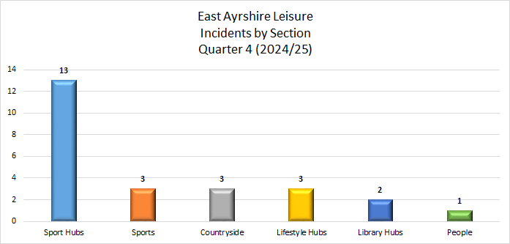

6.3 The following graph shows the ‘Locations’ where incidents occurred during Quarter 4 (2024/25):
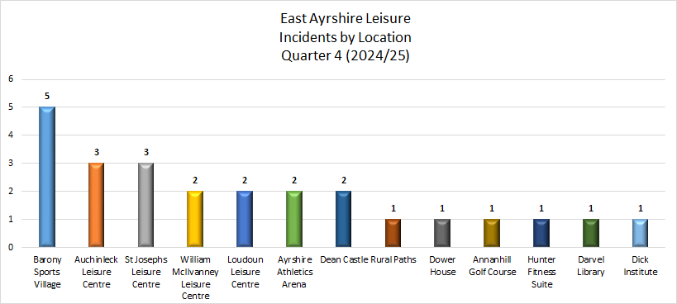

6.4 The graph below depicts those persons who were involved in the 25 incidents:

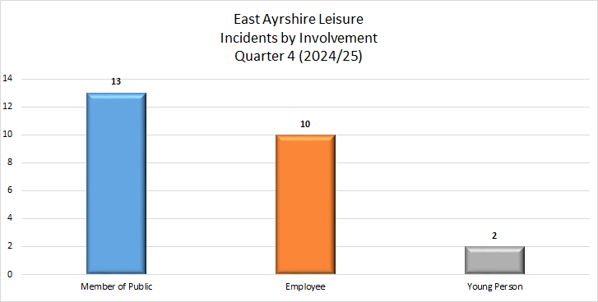

6.5 The following graph depicts the ‘Type’ of all incidents reported during Quarter 4 (2024/25):

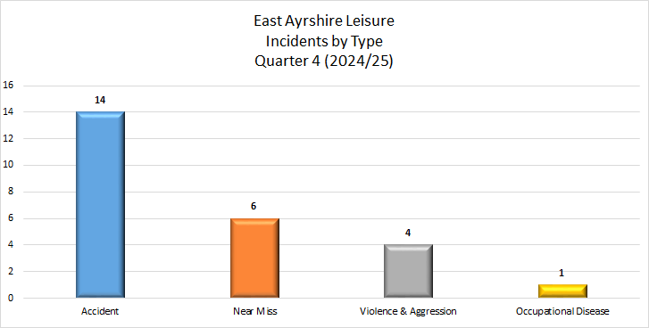

6.6 The graph below depicts the ‘Causes’ of incidents reported during Quarter 4 (2024/25):

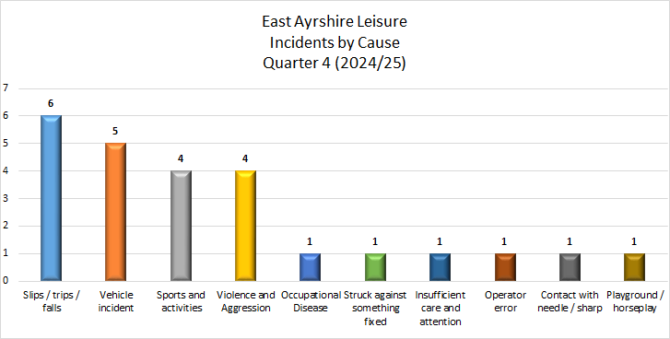

6.7 The graph below details the location of the ‘Violence and Aggression’ incidents during Quarter 4 (2024/25):
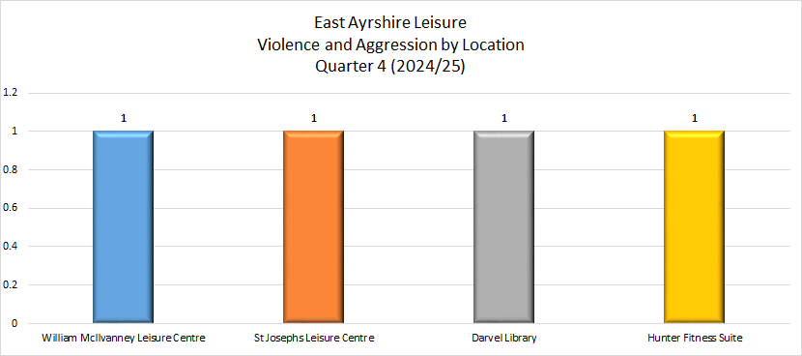
7. Average Days to Report an Incident
7.1 The overall average number of days to report an incident, by East Ayrshire Leisure, during Quarter 4 (2024/25) was 14.8 days.
8. Number of Days Lost due to Workplace Injury
8.1 Of the 25 incidents, 10 incidents involved employees; 2 of which were reported to HSE under RIDDOR. 1 of the incidents resulted in ‘Lost Time’.
8.2 Managers require to notify the Health and Safety Team when employees are absent from work for over 7 days since those incidents may become reportable to HSE under RIDDOR. Notify the Health and Safety section immediately by telephone and update the ‘incident severity’ field within the SHE report.

8.3 Post Incident Interventions

All accidents and incidents reported through SHE are reviewed by the Health and Safety Adviser Team. In order to ensure that managers carry out proportionate investigations of all accidents and incidents which result in lost time injury, all managers will receive an action from Health and Safety to confirm that they have carried out a proportionate investigation to establish if there are any contributory factors.

All corresponding information, such as accident investigation reports and statements, should be logged on SHE for future reference, for example, in the event of a claim for damages being lodged. Where required Accident Investigations are carried out by appropriately trained staff. This section will be updated should an Accident Investigation be carried out.

COMPARATIVE ANALYSIS – 2023/24 v 2024/25

9.1 The line diagram below shows a comparison between Quarter 4 (2023/24) and Quarter 4 (2024/25) for all incidents. Overall the trend shows a decrease in Non-Reportable incidents and an increase in RIDDORs.

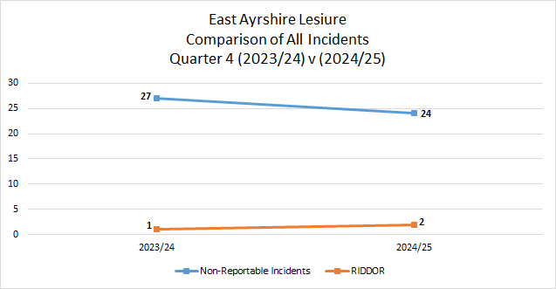

9.2 The graph below demonstrates developing trends in relation to the main causes of incidents when comparing Quarter 4 (2023/24) with Quarter 4 (2024/25):

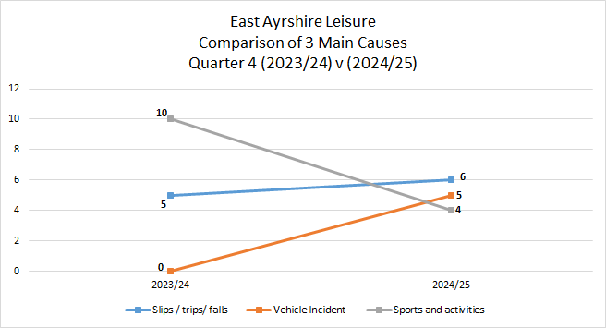

10. CONCLUSIONS

10.1 There were a total of 21 enquiries received during Quarter 4 (2024/25).
10.2 There were a total of 25 incidents reported during Quarter 4 (2024/25).
10.3 Of the 25 incidents reported during Quarter 4 (2024/25); 2 of which were required to be reported to HSE.
10.4 Of the 25 incidents reported, 10 involved employees; 1 of which resulted in ‘time lost’
10.5 Section 7.1 reveals the overall average number of days to report an incident, by the Trust, during Quarter 4 (2024/25) was 14.8 days.

Jane McKie
April 2025

